Part : 1 Feature Extraction

(1) Read the image and Convert it into gray level image :

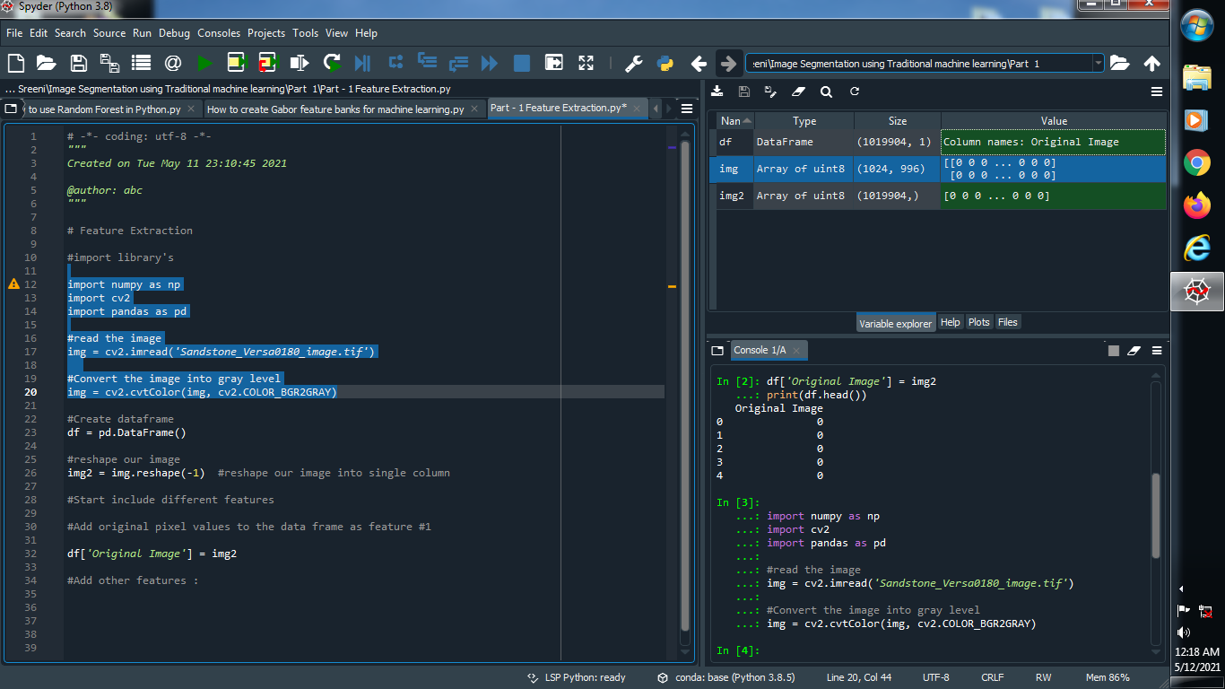

Output :



(2) Reshape our image into single dimension :

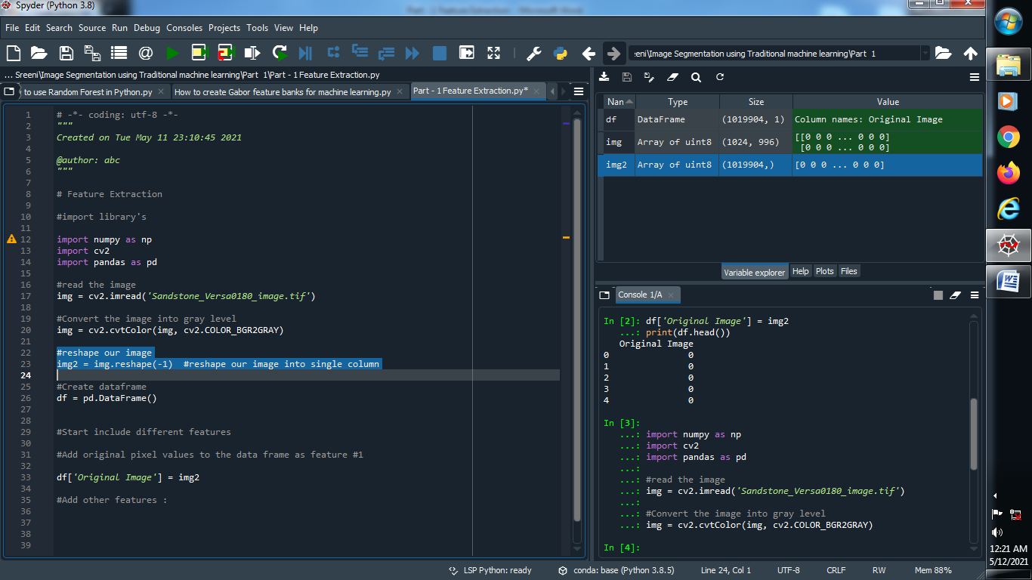

Output :



(3) Create one dataframe and named it’s column name :

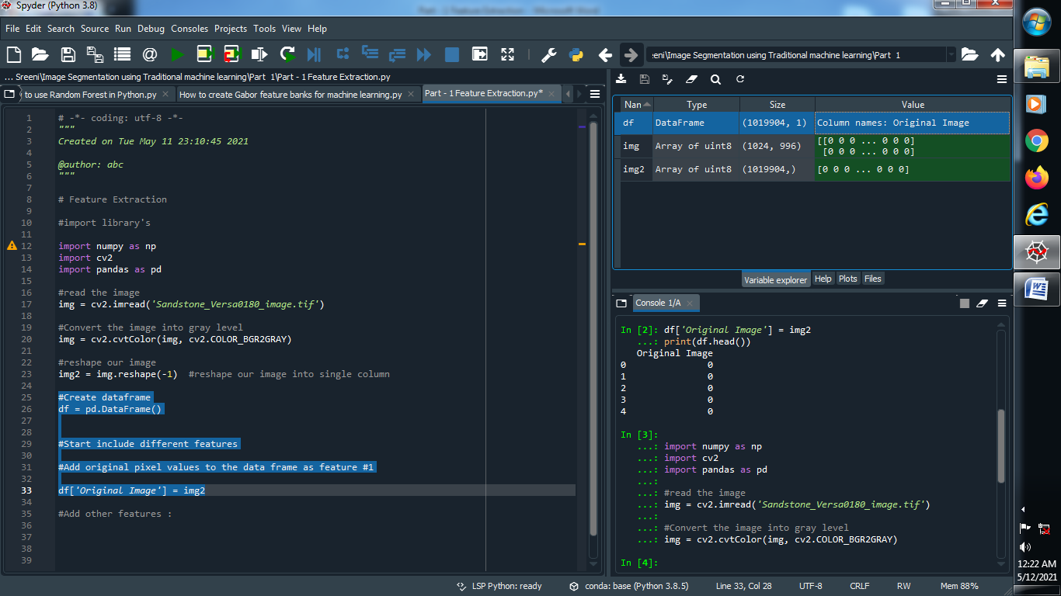

Output :



(4) Add another features :

(I) Gabor features :

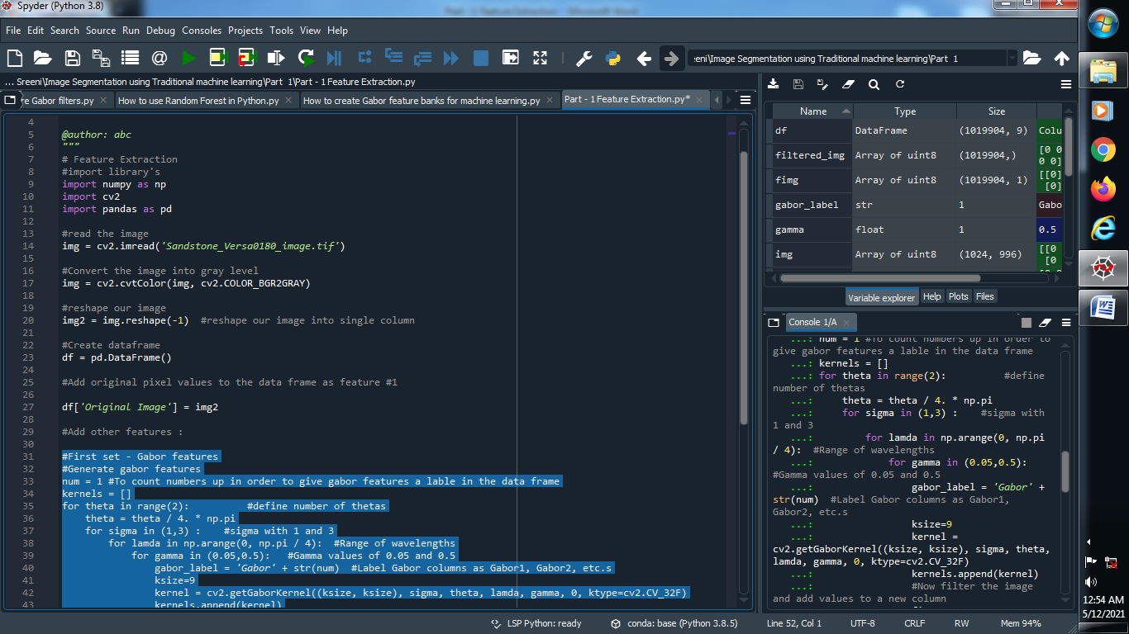

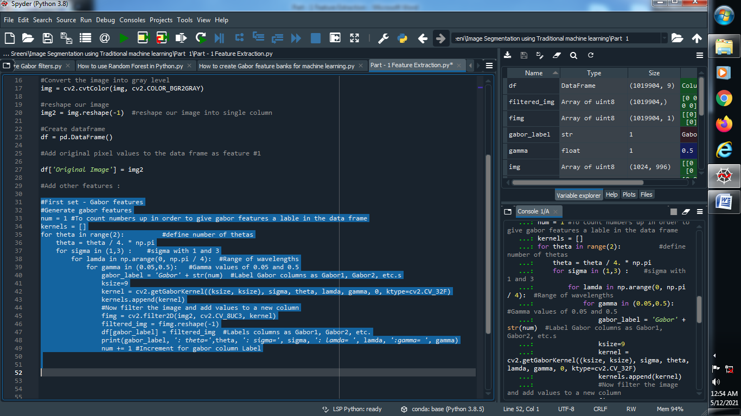

Output :

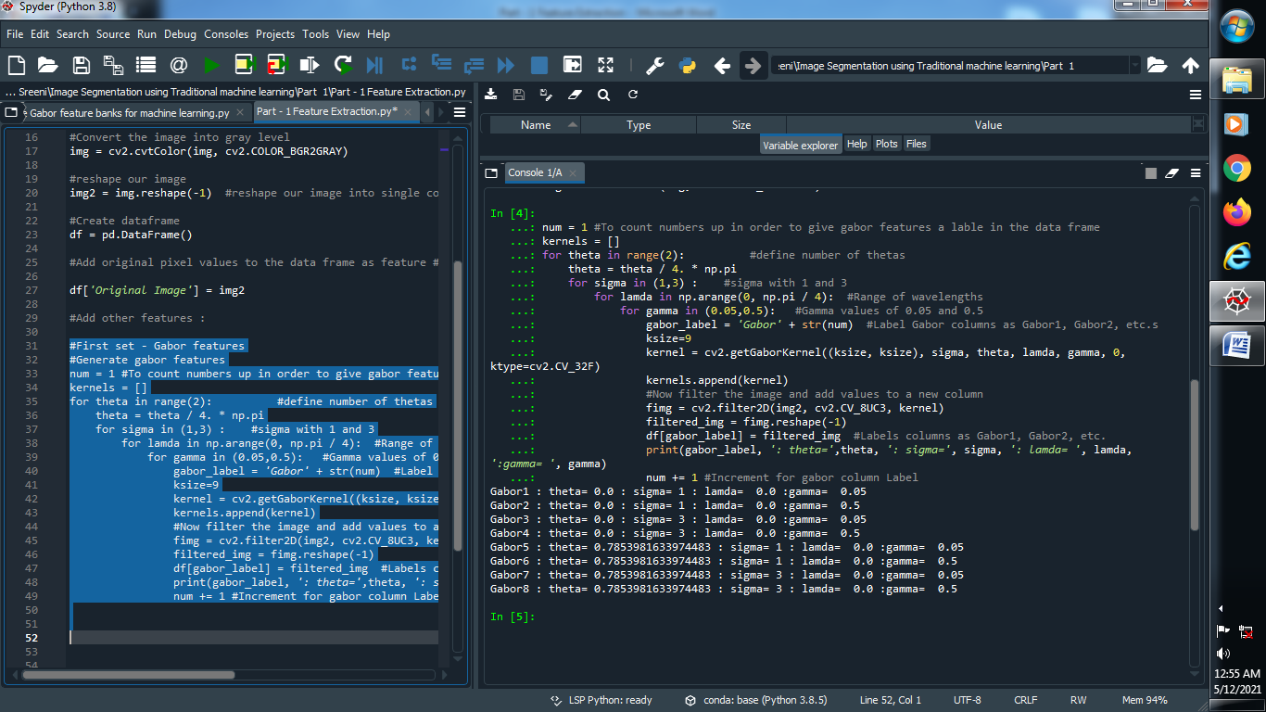

(II) Apply Canny Edge filter :

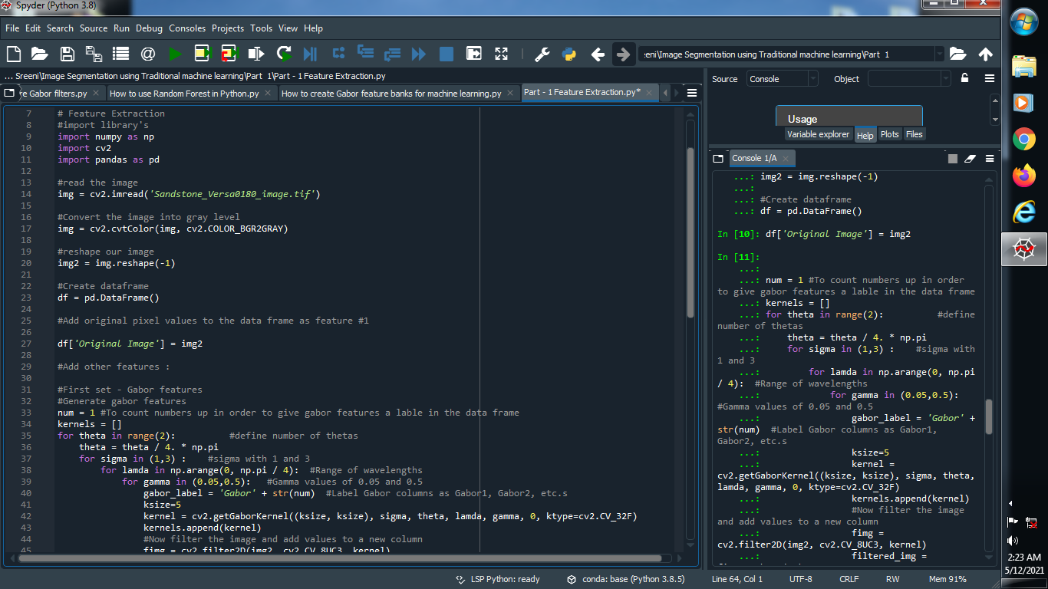

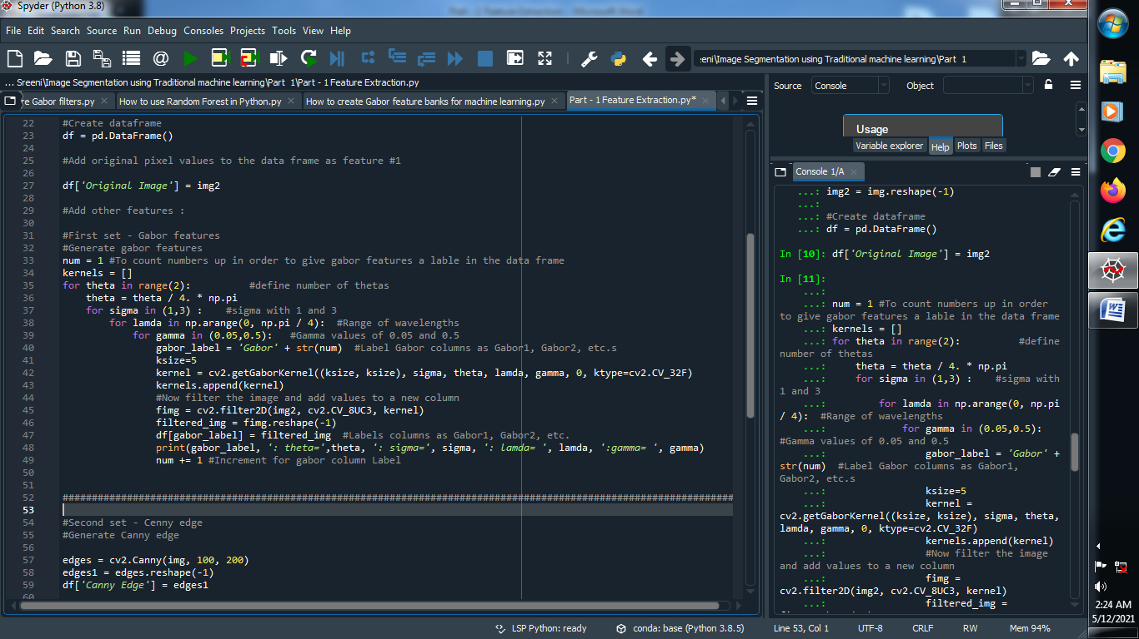

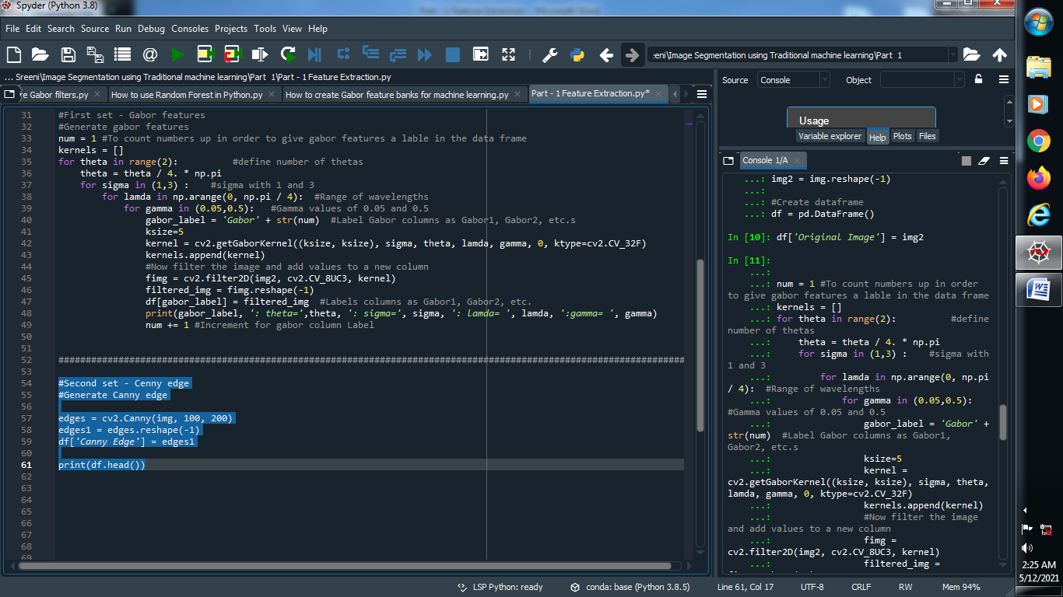

Output :

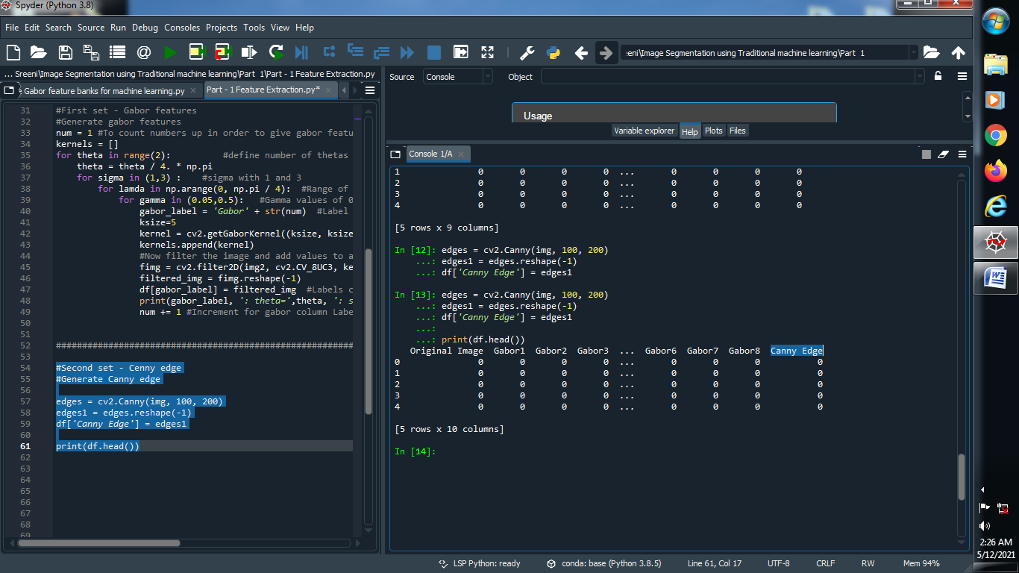

(III) Apply Roberts, sobel, scharr, prewitt, gaussian, median filter :





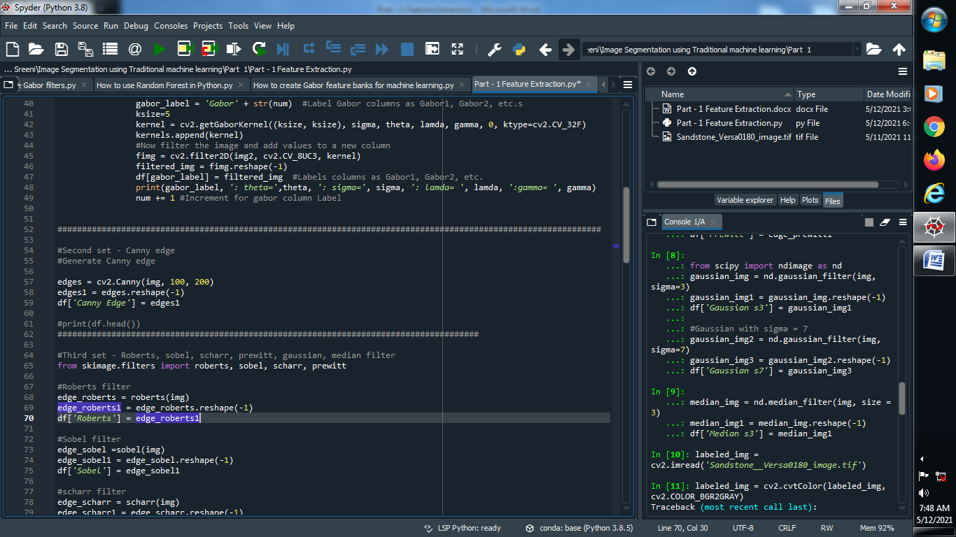

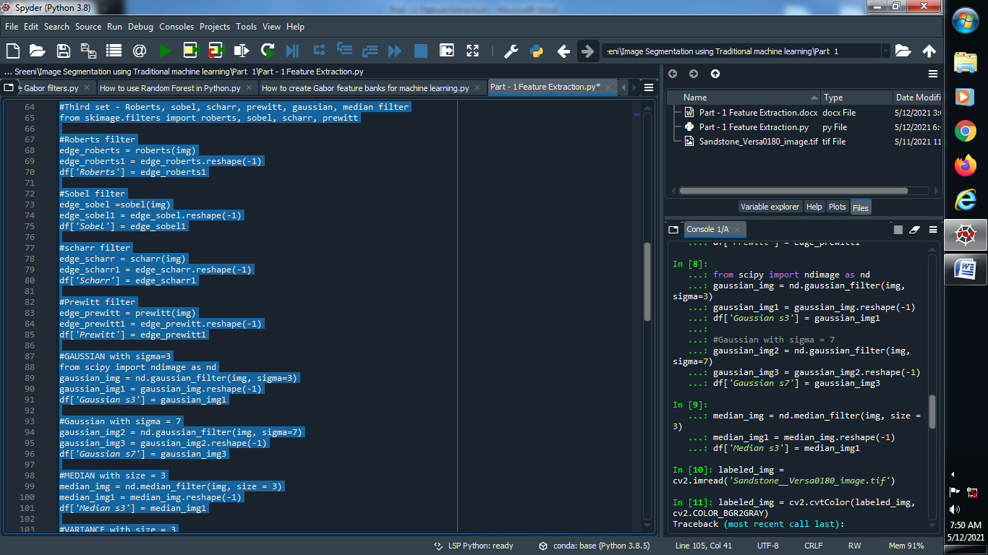

→ Output :

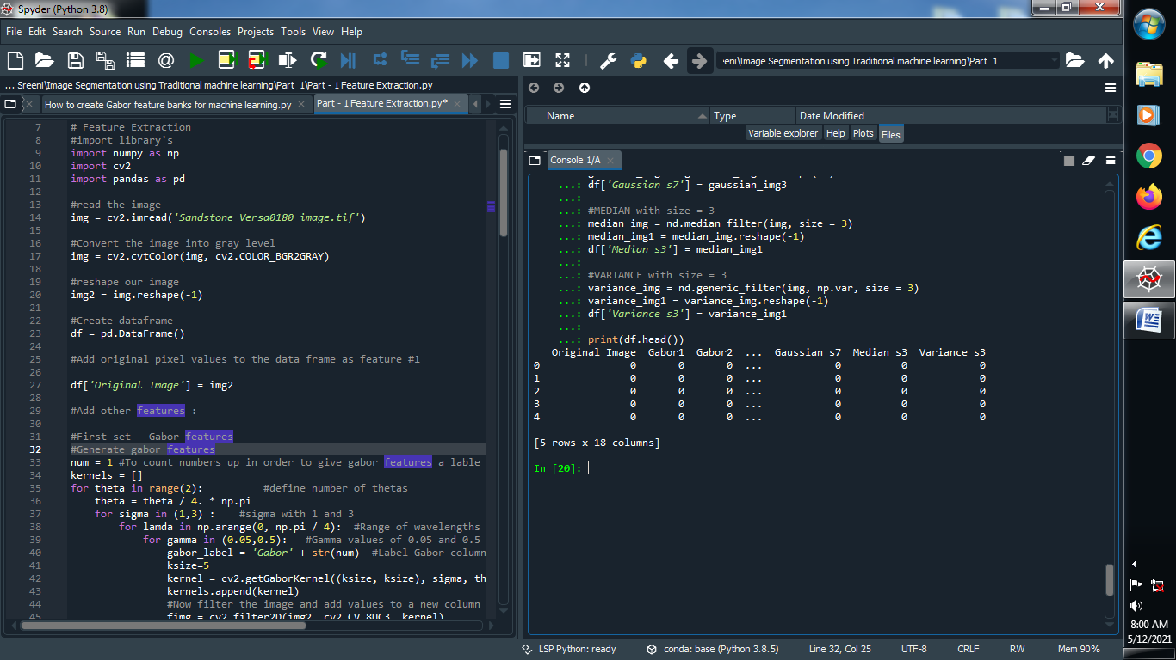

→ Add one column that corresponds to image :

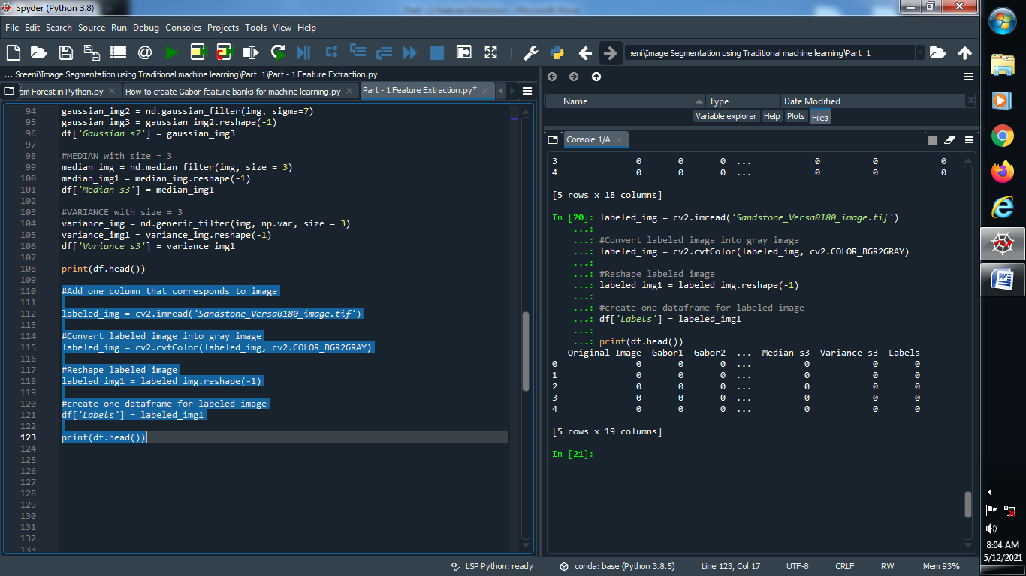

Output :

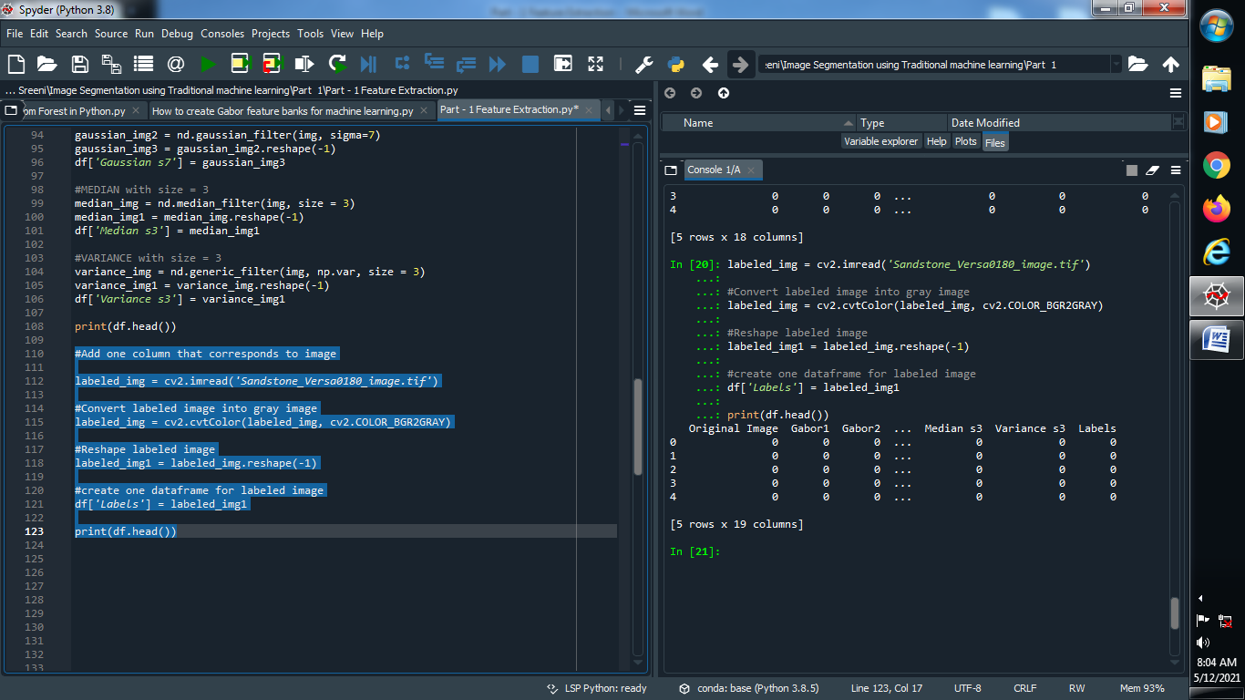

PART : 2 TRAIN A MODEL :

→ Let’s Train our model :

(1) Define dependent and independent variables :

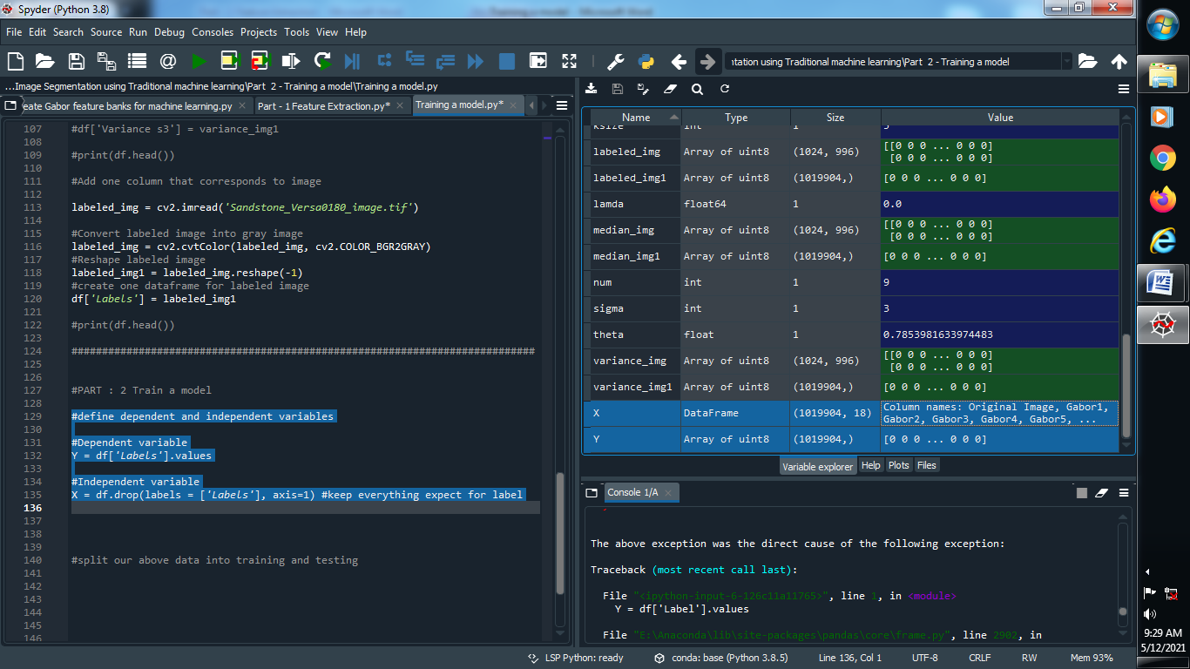

Output :



(2) Split our data into training and testing :

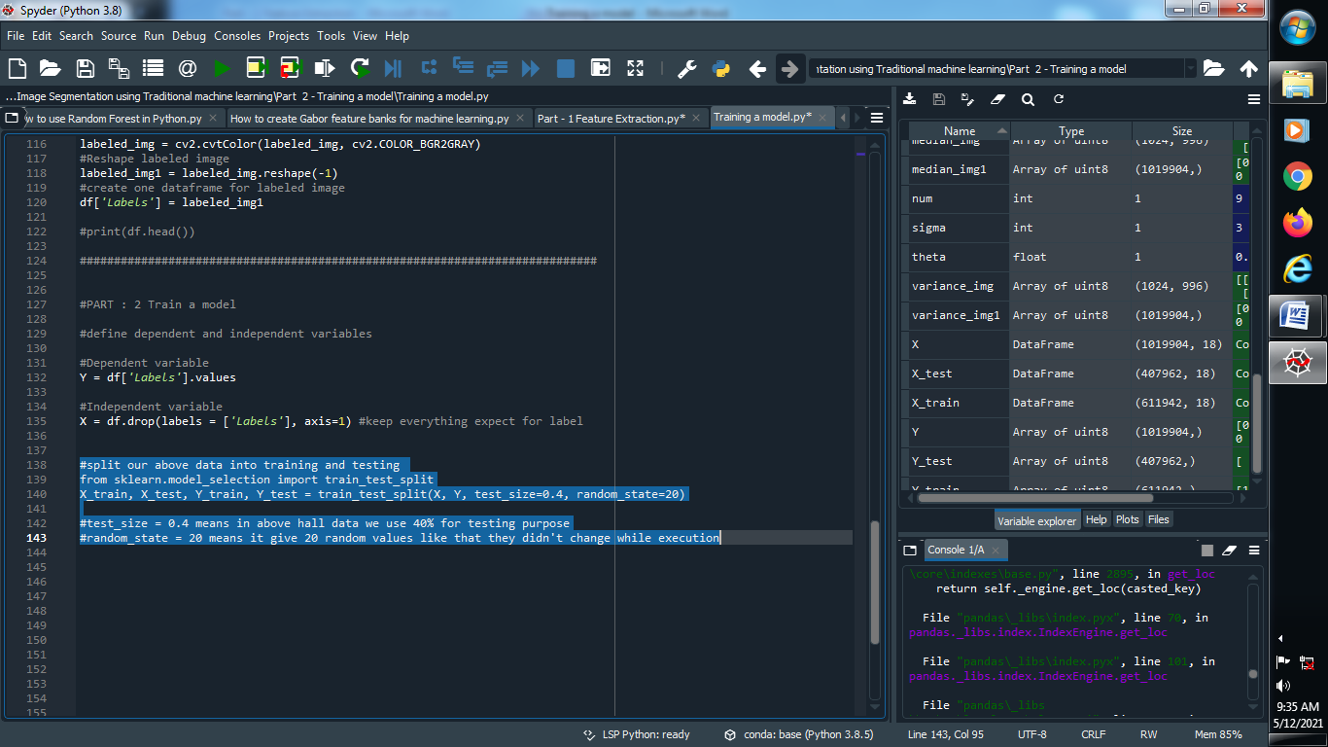

(3) Apply Random Forest Classifier :

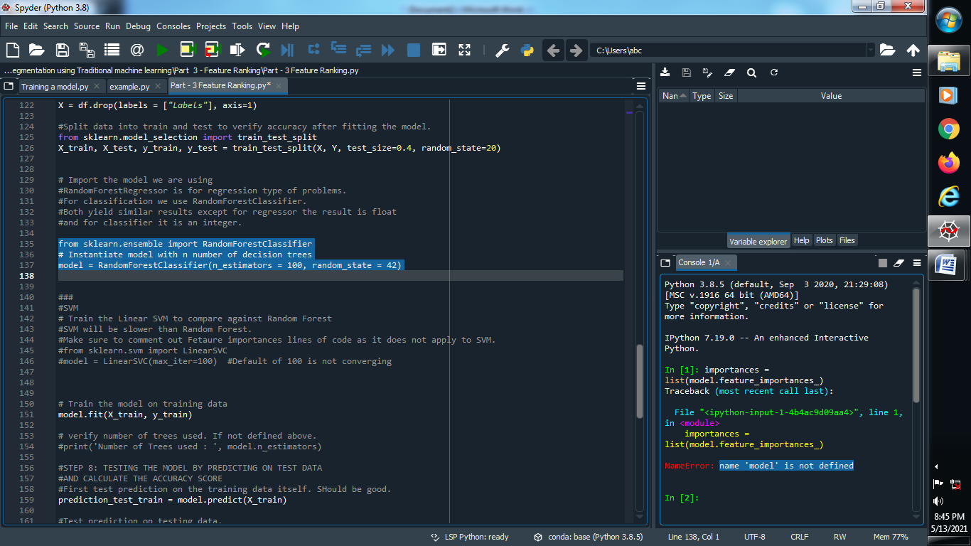

(4) Fit Our model :

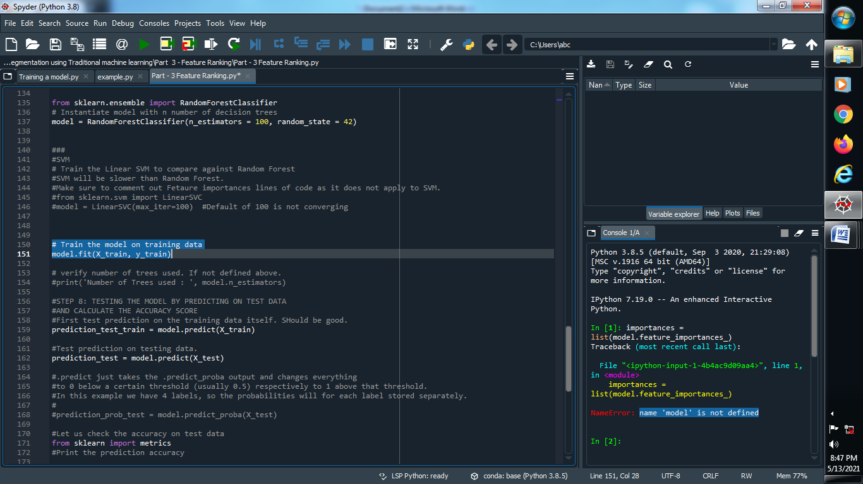

(5) Predict Our training and testing dataset :

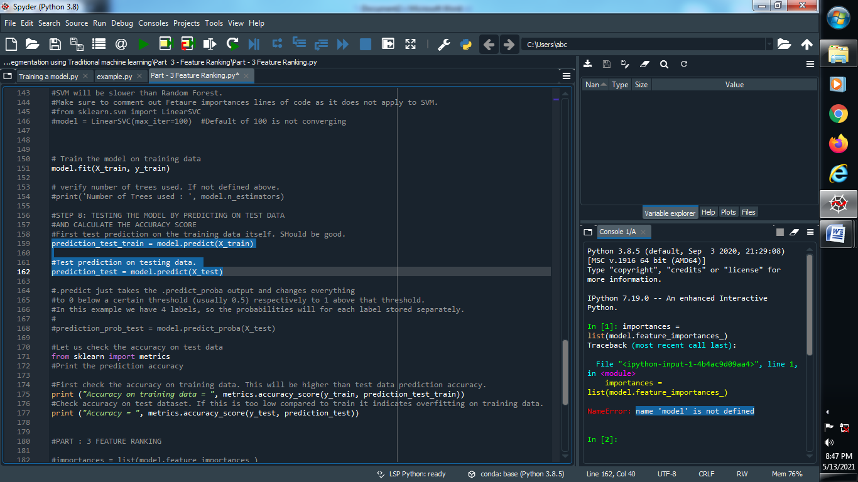

(6) Find the accuracy of our predicted data :

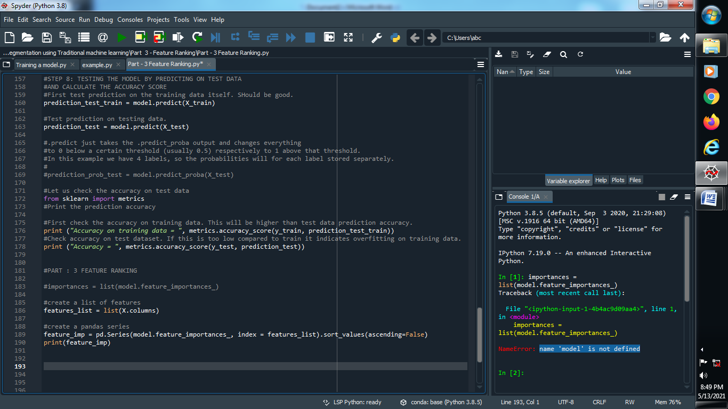

PART : 3 FEATURE RANKING :

(1) Create a list of features :

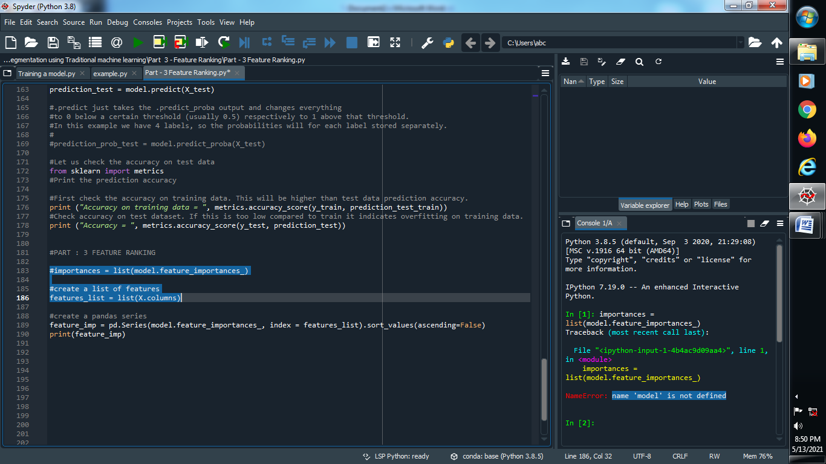

(2) Create a pandas series and print the ranking of our features :

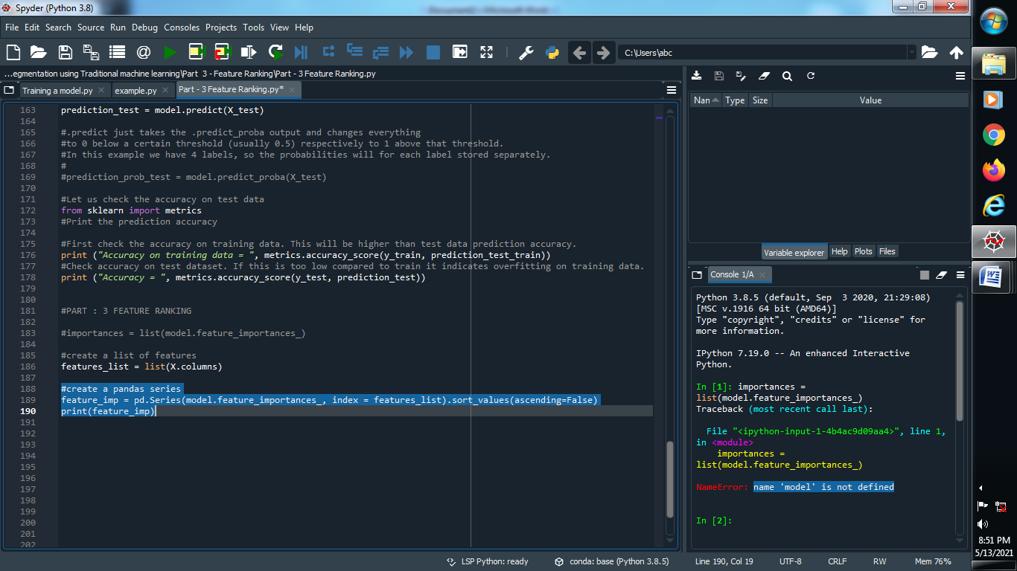

Output :

